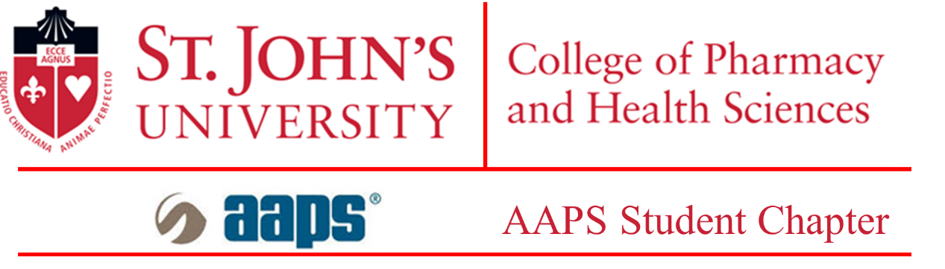

Three-minute Thesis (3MT) Competition

The 3MT is an exciting annual competition for graduate students to showcase their communication skills and present their research to a general audience. It helps students condense their data and focus on important aspects of their research without much deviation.
Please submit this form to Nitesh Kunda, Ph.D., at kundan@stjohns.edu as one single file, by April 4, 2025.
Please note: The word limit for the abstract is 300 words. The file should be saved as a .pdf file with your full name as the file name so that the saved file would say, i.e. ‘John Doe.pdf’. There is a section to write your abstract and title. Please fill the necessary details in this document itself.
Applicant Details

Student Name:
Program of study (Please mark one): M.S.: ☐ Ph.D.: ☐
Major:
St. John’s email address:
Telephone number: +1 ( )-( )-( )
Semester of comprehensive exam completion (Please include the year) (Ph.D. only):
Year and semester of enrollment (M.S. only):
Title of thesis

Abstract (not more than 300 words):

Please read the following and sign:

The 3MT competition will be held on the April 11, 2025, in-person at St. John’s University.
I have informed my mentor of my intention to present and apply to the 3MT competition and I have his/her full support with the same. The 3MT committee will notify me of my selection and provide me with the guidelines and judging criteria.

