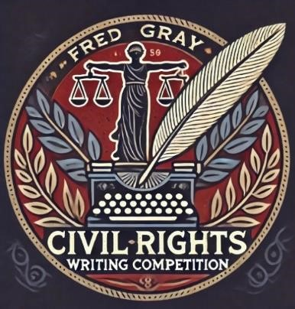

**Competition Overview:**

The FRED GRAY CIVIL RIGHTS WRITING COMPETITION is a prestigious national writing competition honoring the extraordinary contributions of Fred Gray to the civil rights movement. Fred Gray is a renowned civil rights attorney who played a pivotal role in numerous landmark cases that helped dismantle segregation and advance the cause of racial justice in America. Notably, he represented Rosa Parks, Dr. Martin Luther King Jr., and the victims of the Tuskegee Syphilis Study. His legal acumen and unwavering commitment to justice have left an indelible mark on the history of civil rights in the United States.

In 2023, with the generous support of Mark and Becky Lanier, Texas Tech University School of Law established the Fred Gray Endowed Chair for Civil Rights and Constitutional Law to honor Mr. Gray’s profound contributions to the civil rights movement. Now, Texas Tech Law is partnering with The Lanier Law Firm and the Fred D. Gray Institute for Human and Civil Rights to offer the FRED GRAY CIVIL RIGHTS WRITING COMPETITION to law students around the nation.

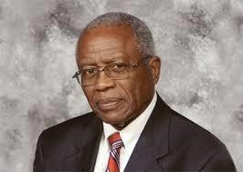

“*Let us not assume for one moment that our work is done, the struggle for equal justice continues*.” – Fred Gray **Writing Competition – Topic Guidelines:**

This writing competition is an opportunity for law students to contribute to the ongoing dialogue on civil rights and to honor the legacy of a legal giant—Fred Gray— whose work continues to inspire justice and equality.

Law students are invited to submit original scholarly essays that are thematically linked to the impactful work of Fred Gray and his contributions to the civil rights movement. Submitted essays should demonstrate thorough research, thoughtful analysis, and original insights while exploring critical civil rights issues, including but not limited to:

* The right to vote;
* The right to be free from racial discrimination;
* The right to government services;
* The right to fair treatment in the criminal justice system including at trial;
* The right to public education; and
* The right to gainful employment.

**Submission Process:**

* **Eligibility:** Any J.D. or LL.M. student—full-time or part-time—currently enrolled in an ABA-Accredited law school may submit an essay.
* **Non-published Original Work:** Only *non-published scholarly works* may be submitted. Please do not submit an essay that (1) has been published, (2) has been submitted for publication, or (3) will be submitted for publication before May 1, 2025. Only single-authored essays will be accepted. Further, a student may submit only one entry per competition year.
* **Essay Length**: Essays must be between 5,000 and 8,000 words, including the title, text, and footnotes.
* **Format**: All essays must be submitted as a PDF document (without any identifying information). Please use 12-point serif font.
* **Citations:** Citations should conform to the current edition of *The Bluebook: A Uniform System of Citation*.
* **Deadline**: The deadline to submit an entry is **11:59 p.m. (CST) on Friday, February 28, 2025**.
* **Submission**: Essays must be submitted using the online competition application. Click [HERE](https://docs.google.com/forms/d/e/1FAIpQLSfqdCzJoBTiu-ZTWYU98fit1hiuOPd_KrDAzasKjhiAAliVVA/viewform?usp=sf_link) to access the online application.

* **Judging:** A group of preeminent lawyers and law professors will score the essays anonymously. In general, essays will be judged on the following criteria: (1) topic/originality; (2) quality and use of authority; (3) legal analysis and reasoning; (4) compliance with grammatical rules and the Bluebook; and (5) overall writing style.
* **Notification of winners:** Winners will be notified on or before May 1, 2025.

**Competition Awards:**

As part of this inaugural writing competition, law students will be awarded the following monetary prizes for their essays:

* **First Place**: $7,500 (The winning essay will also be considered for publication in the Texas Tech Law Review.)
* **Second Place**: $5,000
* **Third Place**: $2,500

The competition partners reserve the right not to award one or more of the prizes if the judges determine that the entries are not of sufficient quality to merit selection.

*Additional recognition*:

* All winning authors may also be invited to attend the Lanier Trial Academy in Houston, Texas, in June 2025, where they will be recognized by trial attorney Mark Lanier. Travel expenses will be covered.
* All winning authors will be featured on the Texas Tech University School of Law’s website and social media platforms, as well as other appropriate platforms.

**Questions:** Please contact Associate Dean Wendy A. Humphrey at wendy.humphrey@ttu.edu or (806) 834-4446.

**The Fred Gray Civil Rights Writing Competition is the result of a partnership between:**

